**NEED A LOCATION FOR A RESTAURANT? HAVE NO FEAR WHEN WE ARE HERE!!**

**1.1 INTRODUCTION/BUSINESS PROBLEM**

In todays fast paced world, we always need to be ready to work long hours or put in our brains to an issue expected to be resolved within the service level agreement! (SLA) Keeping this is mind, it is very much possible that we usually miss out on either of our daily meals (lunch/dinner). People are so engrossed in the assigned tasks that they forget themselves and are entangled in a never-ending rat race.

With most of the 21st century couples working, it becomes extremely difficult for a woman alone to handle the food preparation for work/daily routine at home. Keeping all this in mind, we focused on a single city in India - Mumbai. There is a lot of potential in the restaurant business as food is a basic necessity and is needed by each and every person living in the city. Based on the location data, we can identify which are the places that have a huge number of Indian Restaurants in Mumbai and which places are lacking them.

Places with a high number of restaurants can be further researched upon to find out whether they are in a great demand or have poor demands depending on the foot count of the restaurant. This can be taken as a future scope to the current problem analysis.

**1.2 DATA**

Since I could not find restaurant/local cafe's data on the well known portals for data analysis, I decided to do a web scraping from the Wikipedia page to get a list of all the suburbs/neighborhoods in Mumbai. I cleansed the data first by extracting only those records which had a neighborhood and a defined suburb for it. All data included as 'Other' in Wikipedia page was excluded as I believe the popular demands would surely be for the suburbs and not for those neigborhoods that do not belong to a suburb.

Once the data was cleansed and extracted, I used the pandas dataframe as a frame to store the extracted data. Using the processed data, I extracted the latitude and longitude from Foursquare and added these columns to the dataframe. I then went on to use this data for clustering the different suburbs based on the number of restaurants. I could find a suitable number of clusters using the elbow method and used that number for clustering the data. Then this data was brought forth diagrammatically on a folium map to show the different clusters which can be provided as a base location for any upcoming/new restaurant.

Reference - <https://en.wikipedia.org/wiki/List_of_neighbourhoods_in_Mumbai>

Sample data:

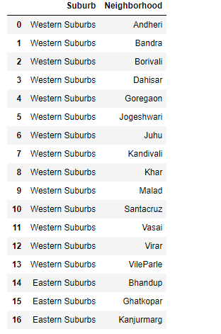

**1.3 METHODOLOGY**

I started with a basic view on the Indian Restaurant business being a foodie considering the option of where exactly would I open a restaurant if at all I wanted to do so myself. To answer this question, I decided to take this problem as my business problem and find a solution for the same. To narrow down to a list of all major suburbs and the number of restaurants in those areas, I used clustering algorithm to divide the neighborhoods into clusters containing a major chunk of Indian restaurants. I then used a folium map to display the clusters and thereby visually understand the places which had very low count of Indian restaurants and which place could be targeted to start a restaurant.

I used the elbow method to get to a decent number of clusters which I then provided as an input to the clustering algorithm. I felt clustering to be appropriate since the algorithm would give me a detailed view on the neighborhoods and their 'Indian Restaurant' content.

**1.4 RESULTS**

Coming to the conclusion that 6 was a decent number of cluster which could be used as the number of clusters, I could see that the clusters were derived based on the Indian Restaurant focused on cluster number 0 and 1 whereas cluster numbers 2, 3 were not so popular for the Indian Restaurant business. Clusters 4 and 5 again had a very few count of Indian Restaurants. Considering the type of neighborhoods in clusters 0 and 1, I could narrow down to a fact that either Bandra or Chembur could be selected as a good starting point for the Indian Restaurant business.

I am from Mumbai and stay in Kurla hence was easily able to locate the best spot out of the cluster entries that could be chosen as a point to initiate the Restaurant business based on the clusters.

Sample Result set Count:

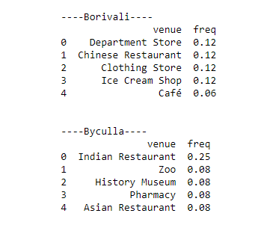

Folium map:

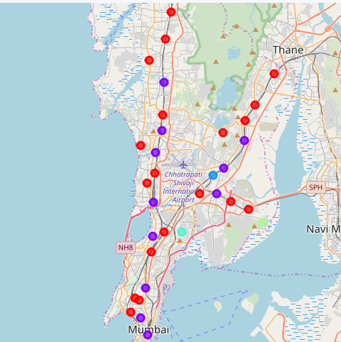

**DISCUSSION**

Although I had a fair idea that Bandra and Chembur being prime locations in Mumbai in terms of Residential and Financial buildings, there was a possibility we could have a great deal of restaurants already present in those locations, I wanted to be double sure that this was the case using actual data which was available. As it does turn out, my guess was correct and we do have a great deal of restaurants in these locations.

However, who does not love good food, right?!! Taking a step in the Restaurant business would surely involve risk and what better place to take the risk than which has a high count of office goers. They require food to go about their daily routine and are willing to spend more than a expected if the quality and ambience of the restaurant is excellent. The only point of concern would be the initial days. Once a restaurant is established, it can easily sustain itself for the next 50-100 years as the industries are not expected to migrate from these neighborhoods.

**CONCLUSION**

Overall, I would like to say that using actual data and working with data to arrive to conclusions is the most accurate way to kick start your own Restaurant business. What better place to go for than Chembur or Dadar?!! Hence, need to start a restaurant business? Have no fear when we are here!!